Tunisia

## Respect for rule of law (ROL) data

The data set shows the data on the respect of the rule of law for the country.

## # A tibble: 19 x 5  
## country iso3c date ruleOfLaw ruleOfLawCategory4   
## <chr> <chr> <dbl> <dbl> <chr>   
## 1 Tunisia TUN 1996 -0.303 ROL moderately disrespected  
## 2 Tunisia TUN 1998 -0.235 ROL moderately disrespected  
## 3 Tunisia TUN 2000 -0.216 ROL moderately disrespected  
## 4 Tunisia TUN 2002 -0.122 ROL moderately disrespected  
## 5 Tunisia TUN 2003 -0.143 ROL moderately disrespected  
## 6 Tunisia TUN 2004 0.0474 ROL moderately respected   
## 7 Tunisia TUN 2005 -0.0129 ROL moderately disrespected  
## 8 Tunisia TUN 2006 0.114 ROL moderately respected   
## 9 Tunisia TUN 2007 0.0858 ROL moderately respected   
## 10 Tunisia TUN 2008 0.0725 ROL moderately respected   
## 11 Tunisia TUN 2009 0.130 ROL moderately respected   
## 12 Tunisia TUN 2010 0.0617 ROL moderately respected   
## 13 Tunisia TUN 2011 -0.132 ROL moderately disrespected  
## 14 Tunisia TUN 2012 -0.129 ROL moderately disrespected  
## 15 Tunisia TUN 2013 -0.189 ROL moderately disrespected  
## 16 Tunisia TUN 2014 -0.110 ROL moderately disrespected  
## 17 Tunisia TUN 2015 -0.0616 ROL moderately disrespected  
## 18 Tunisia TUN 2016 0.00210 ROL moderately respected   
## 19 Tunisia TUN 2017 0.0713 ROL moderately respected

## Respect for rule of law (ROL) trend

The plot shows the trend of the respect for the rule of law for the country.

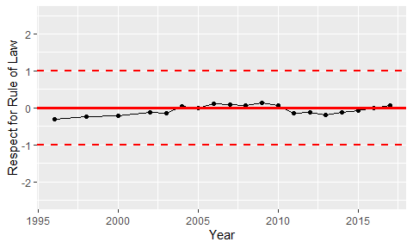

Trend of the Respect for the Rule of Law